/* Bicyclists can calculate their speed if the gear size and cadence is known.
Gear size refers to the effective diameter of the wheel. Gear size multiplied by pi (3.14)
gives the distance travelled with one turn of the pedals. Cadence refers to the number of pedal
revolutions per minute (rpm). The speed in miles per hour is calculated by the following:

This is a program that calculates the speed for a gear size of 100 inches and a cadence of
90 rpm. This would be considered a high cadence and a maximum gear size for a typical bicycle.
1/12 will result in 0, because both 1 and 12 are integers, and when the
*/

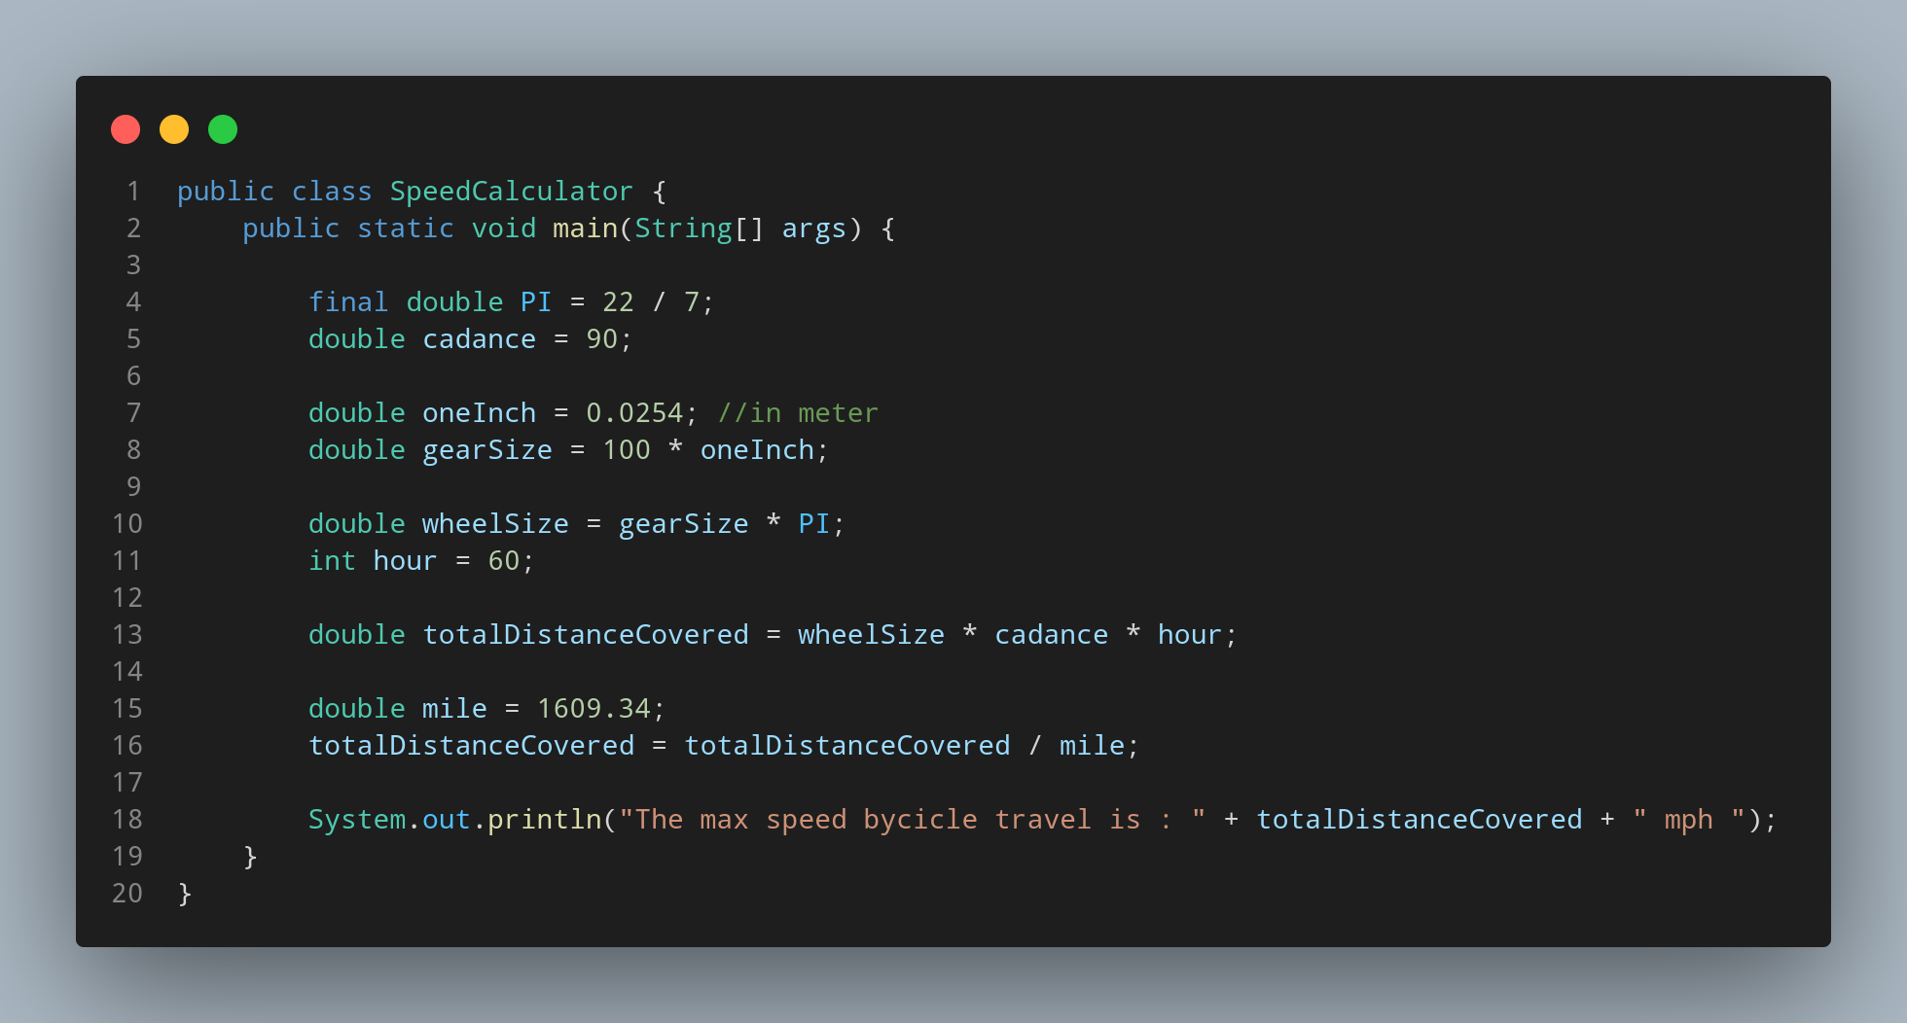

#Doc

File name SpeedCalculator is created so we create a class name SpeedCalculator, inside the class we created a main function. First lets create a constant to store the value of PIE. Then lets store our given data into our variable . We create variable name cadance, oneInch to store how much one Inch is in meter, gearSize, totalDistanceCovered to store the distance travel by the cycle, mile to store how much 1 mile is . Then we calculate our totalDistanceCovered in mph.
At Last we print our data with appropriate sentence.

